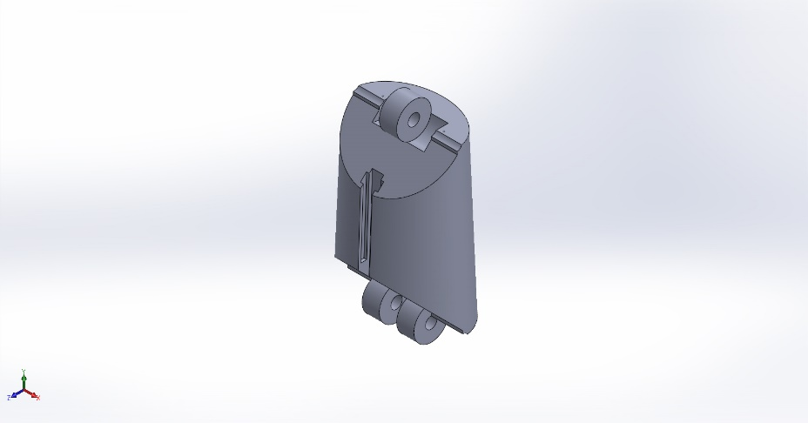
  Simulation of Part1i
  Date: 6 Aralık 2025 Cumartesi
  Designer: Solidworks
  Study name: Static 1
  Analysis type: Static
  Table of Contents
  Description 1
  Assumptions 2
  Model Information 2
  Study Properties 3
  Units 3
  Material Properties 4
  Loads and Fixtures 4
  Connector Definitions 5
  Interaction Information 5
  Mesh information 5
  Sensor Details 6
  Resultant Forces 6
  Beams 6
  Study Results 7
  Conclusion 9

Description
No Data

Assumptions

Model Information

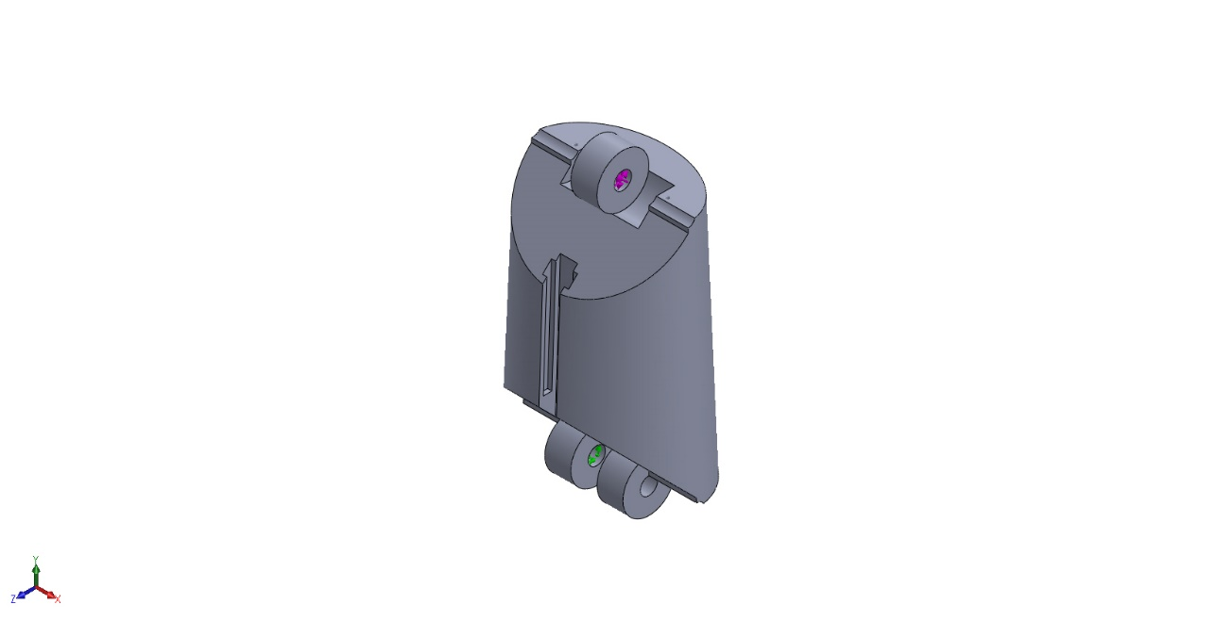
Model name: Part1i
Current Configuration: Default
Solid Bodies
Document Name and Reference | Treated As | Volumetric Properties | Document Path/Date Modified
Scale2  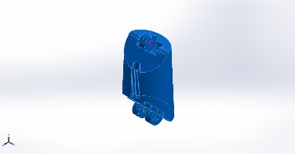 | Solid Body | Mass:0,00642201 kg  Volume:5,0567e-06 m^3  Density:1.270 kg/m^3  Weight:0,0629357 N | C:\Users\Asus\OneDrive\Masaüstü\BİTİRME\MST\Index&ring\Part1i.SLDPRT

Study Properties
Study name | Static 1
Analysis type | Static
Mesh type | Solid Mesh
Thermal Effect: | On
Thermal option | Include temperature loads
Zero strain temperature | 298 Kelvin
Include fluid pressure effects from SOLIDWORKS Flow Simulation | Off
Solver type | Automatic
Inplane Effect: | Off
Soft Spring: | Off
Inertial Relief: | Off
Incompatible bonding options | Automatic
Large displacement | On
Compute free body forces | On
Friction | Off
Use Adaptive Method: | Off
Result folder | SOLIDWORKS document (C:\Users\Asus\OneDrive\Masaüstü\BİTİRME\MST\Index&ring)

Units
Unit system: | SI (MKS)
Length/Displacement | mm
Temperature | Celsius
Angular velocity | Rad/sec
Pressure/Stress | N/mm^2 (MPa)

Material Properties
Model Reference | Properties | Components
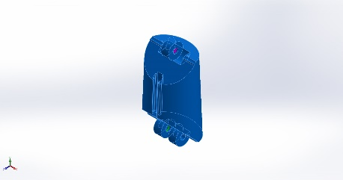 |  | SolidBody 1(Scale2)(Part1i)
  Name: | PETG
  Model type: | Linear Elastic Isotropic
  Default failure criterion: | Unknown
  Yield strength: | 40 N/mm^2
  Tensile strength: | 50 N/mm^2
  Elastic modulus: | 2.000 N/mm^2
  Poisson's ratio: | 0,4
  Mass density: | 1,27 g/cm^3
  Shear modulus: | 318,9 N/mm^2
Curve Data:N/A

Loads and Fixtures
Fixture name | Fixture Image | Fixture Details
Fixed-1 | 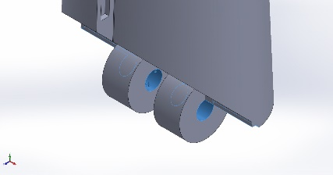
  Entities: | 2 face(s)
  Type: | Fixed Geometry
Resultant Forces
Components | X | Y | Z | Resultant
Reaction force(N) | -0,000108286 | 0,000606802 | 0,0015744 | 0,00169076
Reaction Moment(N.m) | 0 | 0 | 0 | 0

Load name | Load Image | Load Details
Force-1 | 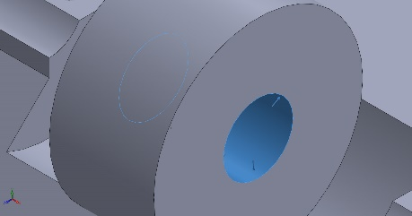
  Entities: | 1 face(s)
  Type: | Apply normal force
  Value: | 30 N

Connector Definitions
No Data

Interaction Information
No Data

Mesh information
Mesh type | Solid Mesh
Mesher Used: | Curvature-based mesh
Jacobian points for High quality mesh | 16 Points
Maximum element size | 3,43536 mm
Minimum element size | 0,171768 mm
Mesh Quality | High

Mesh information - Details
Total Nodes | 101073
Total Elements | 69469
Maximum Aspect Ratio | 12,451
% of elements with Aspect Ratio < 3 | 95,8
Percentage of elements with Aspect Ratio > 10 | 0,00288
Percentage of distorted elements | 0
Time to complete mesh(hh;mm;ss): | 00:00:04
Computer name:

Sensor Details
No Data

Resultant Forces

Reaction forces
Selection set | Units | Sum X | Sum Y | Sum Z | Resultant
Entire Model | N | -0,000108286 | 0,000606802 | 0,0015744 | 0,00169076

Reaction Moments
Selection set | Units | Sum X | Sum Y | Sum Z | Resultant
Entire Model | N.m | 0 | 0 | 0 | 0

Free body forces
Selection set | Units | Sum X | Sum Y | Sum Z | Resultant
Entire Model | N | 0 | 0 | 0 | 0

Free body moments
Selection set | Units | Sum X | Sum Y | Sum Z | Resultant
Entire Model | N.m | 0 | 0 | 0 | 0

Beams
No Data

Study Results

Name | Type | Min | Max
Stress1 | VON: von Mises Stress | 0,000N/mm^2 (MPa)  Node: 14627 | 3,226N/mm^2 (MPa)  Node: 545
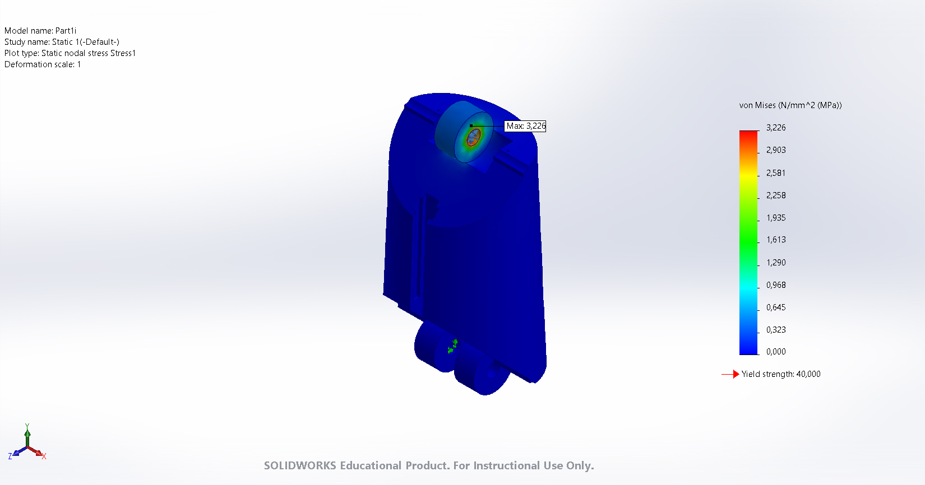
Part1i-Static 1-Stress-Stress1

Name | Type | Min | Max
Displacement1 | URES: Resultant Displacement | 0,000mm  Node: 5 | 0,002mm  Node: 14223
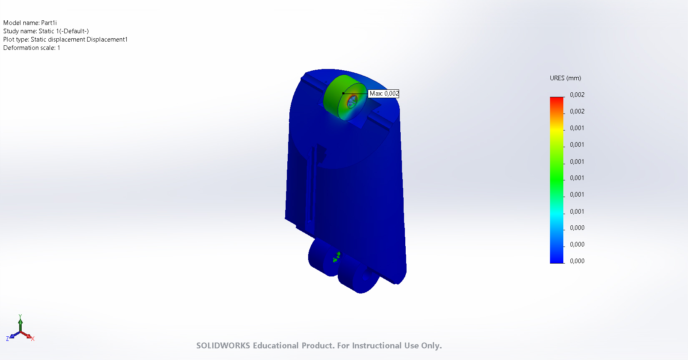
Part1i-Static 1-Displacement-Displacement1

Name | Type | Min | Max
Strain1 | ESTRN: Equivalent Strain | 0,000  Element: 28250 | 0,001  Element: 32206
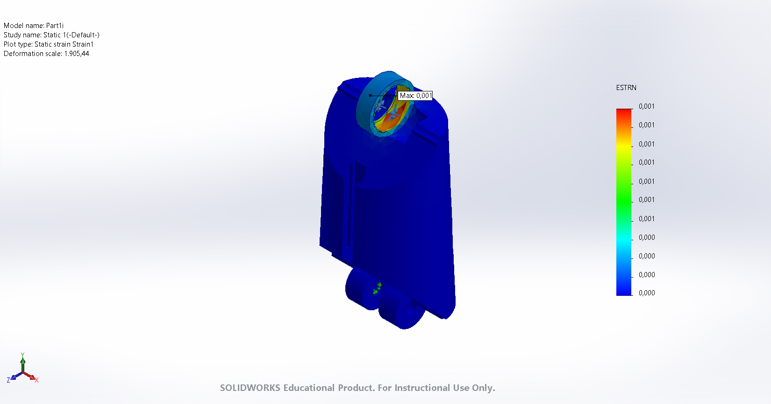
Part1i-Static 1-Strain-Strain1

Name | Type | Min | Max
Factor of Safety1 | Automatic | 10,000  Node: 1 | 10,000  Node: 1
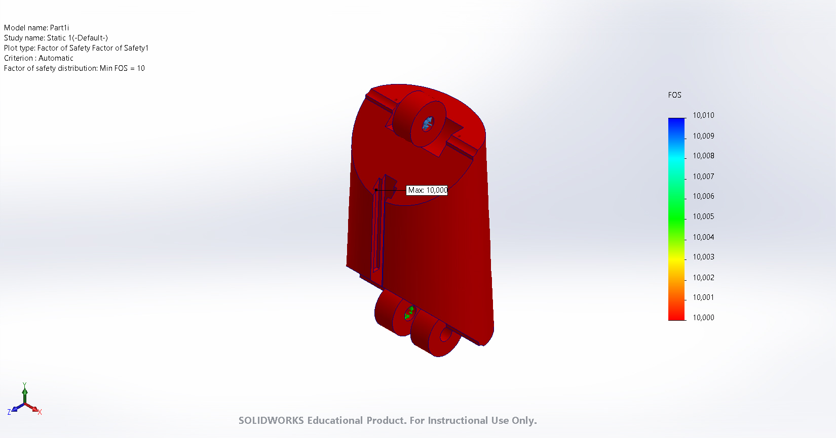
Part1i-Static 1-Factor of Safety-Factor of Safety1

Conclusion

